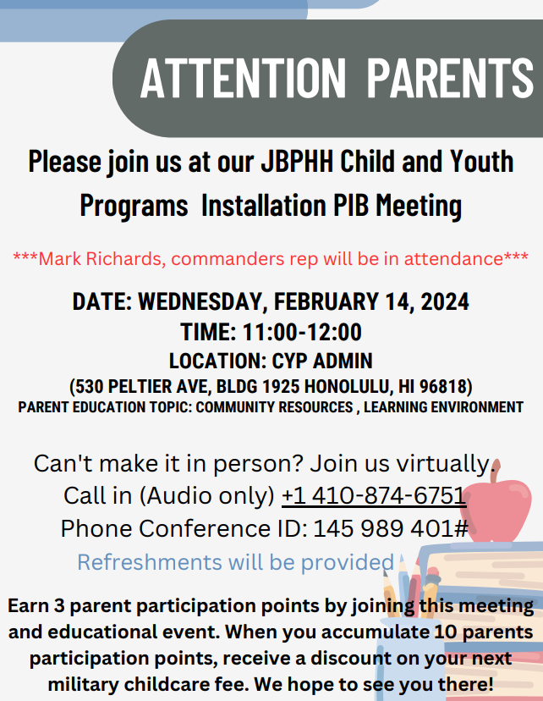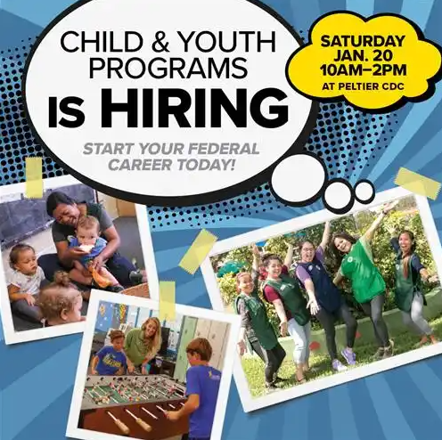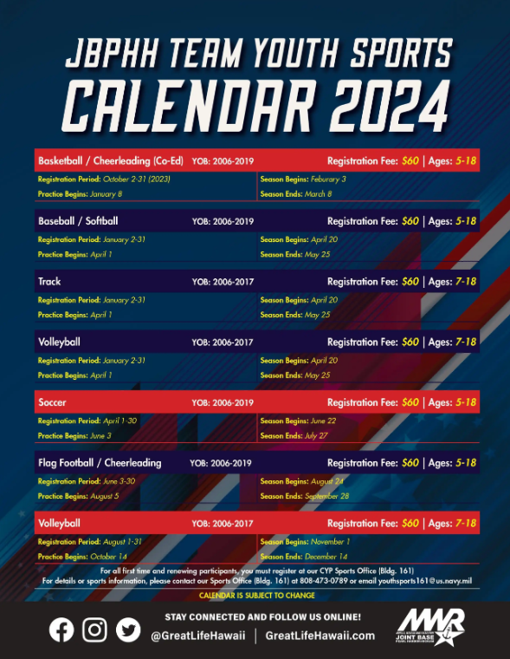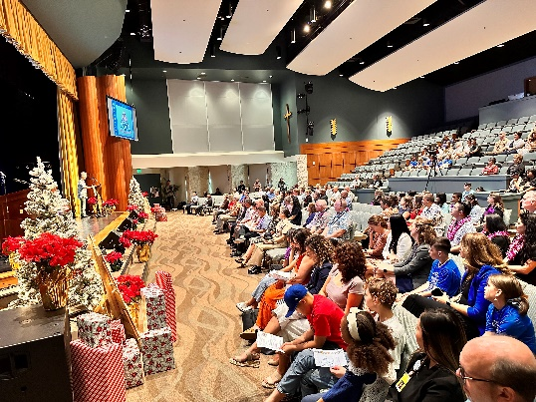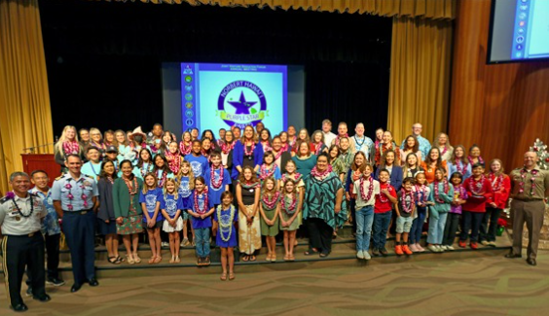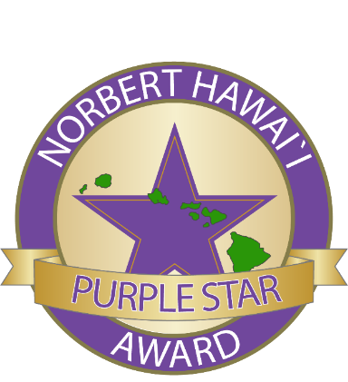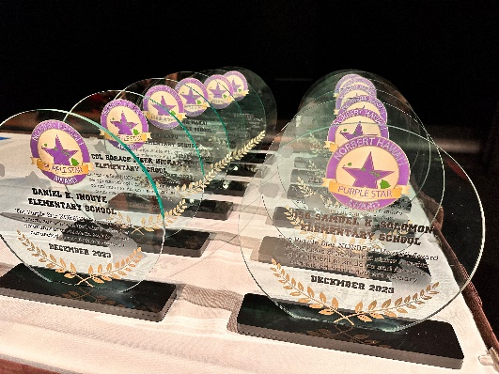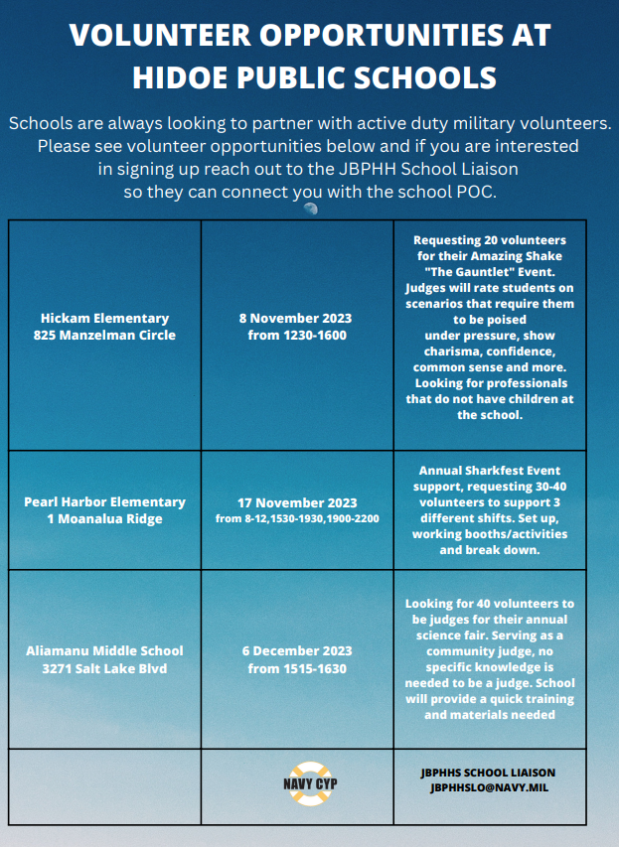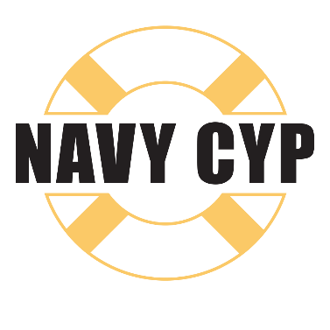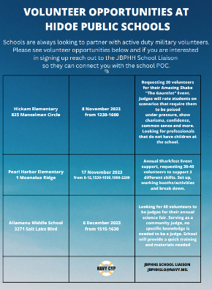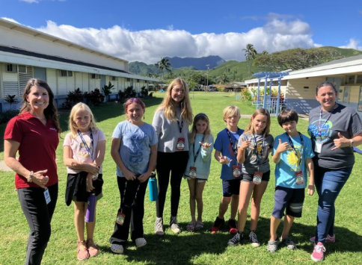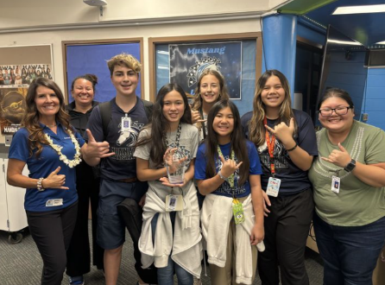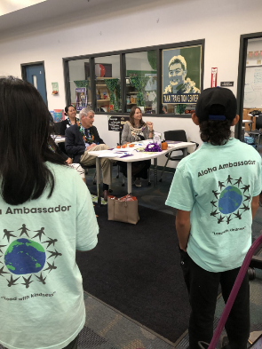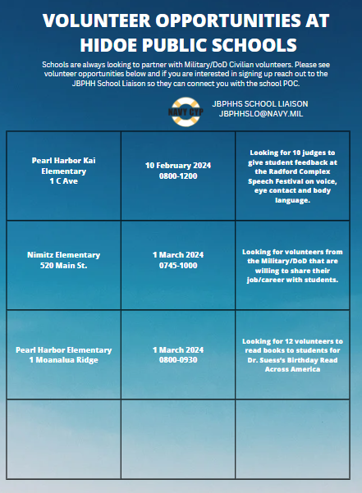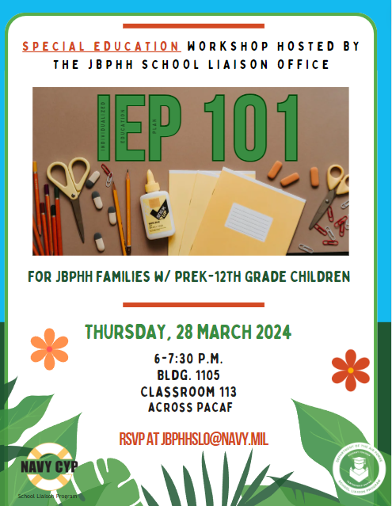

We are always looking for amazing workers who love working with children. Hiring for Child Development Center (CDC) Program Staff, School Age Care (SAC) Program Staff, Youth Sports and Teen Center Program Staff. Hours vary and there are great incentives that you earn.

Upcoming Parent Involvement Board Meeting for Child & Youth Families, please join us!

Find the Youth Sport Calendars on; [Youth Sports (greatlifehawaii.com)](https://jbphh.greatlifehawaii.com/family/youth-sports)

SCHOOL LIAISON NEWSLETTER SHARING EDUCATIONAL INFORMAITON THAT AFFECTS MILITARY CHILDREN AT JOINT BASE PEARL HARBOR-HICKAM, HAWAII

**Child & Youth Programs**

1SG Samuel K. Solomon Elementary School

Daniel K. Inouye Elementary School

‘Ewa Beach Elementary School

Lt. Col. Horace Meek Hickam Elementary School

Major Sheldon Wheeler Elementary School

Mōkapu Elementary School

Āliamanu Middle School

‘Ewa Makai Middle School

Major Sheldon Wheeler Middle School

Admiral Arthur W. Radford High School

Kalāheo High School

Leilehua High School

Twelve O‘ahu public schools have been recognized for creating a welcoming and safe environment for incoming military-dependent and transitioning students enrolling at their campuses.   
  
The schools were awarded with the Purple Star NORBERT Hawai'i Award by the Joint Venture Education Forum (JVEF), a partnership between Hawaiʻi's military community, the Hawaiʻi Department of Education (HIDOE) and other community organizations.

Instituted in 2006, the NORBERT Award represents a "stamp of excellence" for schools that meet the required award criteria. The origin of the name “NORBERT” is a combination of the names of the first two recognized schools' principals – Norman Minehira of Leilehua High, and Robert Stevens of Radford High. The Purple Star NORBERT Hawaiʻi Award now combines the NORBERT Award with the Purple Star School Program.

The Purple Star School Program is designed to assist and recognize schools that respond to the educational and social-emotional challenges faced by military-connected children during their transition to a new school and their work to keep these students on track to be college, workforce, and community-ready. The award criteria includes having student-led transition services for incoming and outgoing students, addressing key educational transition issues encountered by children of military families, participating and engaging in military partnerships, and having an effective parent and community network program.

The awardees are the first to be recognized as Purple Star NORBERT Hawai'i schools during JVEF’s annual meeting held Dec. 14:

**12 Hawaii Department of Education Schools Awarded the Purple Star NORBERT Hawaii Award**

Jan-Mar 2024 Edition

TRANSITION SUPPORT

SPECIAL EDUCATION

PARTNERSHIPS IN EDUCATION

**Hui KULA**

CURRENT EVENTS

**TABLE OF CONTENTS**

CHILD & YOUTH PROGRAMS

**Transition Support**

**Transition Program Highlight: Anchored4Life**

A4L is a club of kids helping kids to make connections and improve self-esteem during seasons of change like, moving, deployment, fear, healthy bodies, reintegration, homework, bullying and more.

Anchored4Life Goals

* Teach and reinforce life skills for youth to make connections when being supported by A4L change topics.
* Provide growing opportunities to increase competency and character by positively addressing setbacks.
* Build confidence leaders who inspire others by contributing to a caring and supportive environment.

This Navy funded program is at 21 schools here on Oahu;

Aliamanu Elementary

Aliamanu Middle

Daniel K. Inouye Elementary

Ft. Shafter Elementary

Hickam Elementary

Ho’okele Elementary

Hono’uli’uli Middle

Ewa Makai Middle

Kailua Intermediate

Kainalu Elementary

Makalapa Elementary

Moanalua Middle

Mokulele Elementary

Nimitz Elementary

Pearl Harbor Elementary

Pearl Harbor Kai Elementary

Red Hill Elementary

Solomon Elementary

Webling Elementary

Wheeler Elementary

Wheeler Middle

Individual Education Plans (IEPs) are intimidating and very layered. There are laws in place to make sure all children are afforded a Free and Appropriate Education (FAPE) and IEP’s help children with special needs get that. Join us on 28 March for a FREE IEP Workshop with esteemed trainer from Leaderships in Disabilities and Achievements of Hawai’i (LDAH), Rosie Rowe. She will bring a wealth of knowledge and be able to answer questions you have regarding IEPs.

RSVP by 22 March to [jbphhslo@navy.mil](mailto:jbphhslo@navy.mil)

**Special Education**

**School Partnerships**

Schools love having military members volunteering on their campuses. You’ll bring a wealth of knowledge and skills to the student’s education experience. Volunteer opportunities vary and you can reach out to the JBPHH School Liaison and they’ll be able to share upcoming opportunities at schools.

Example Volunteer Opportunities include;

* Career Day Speakers
* Judges
* Event Set up and tear down
* Running activity booths
* Campus improvement
* Reading to students
* And much more….

