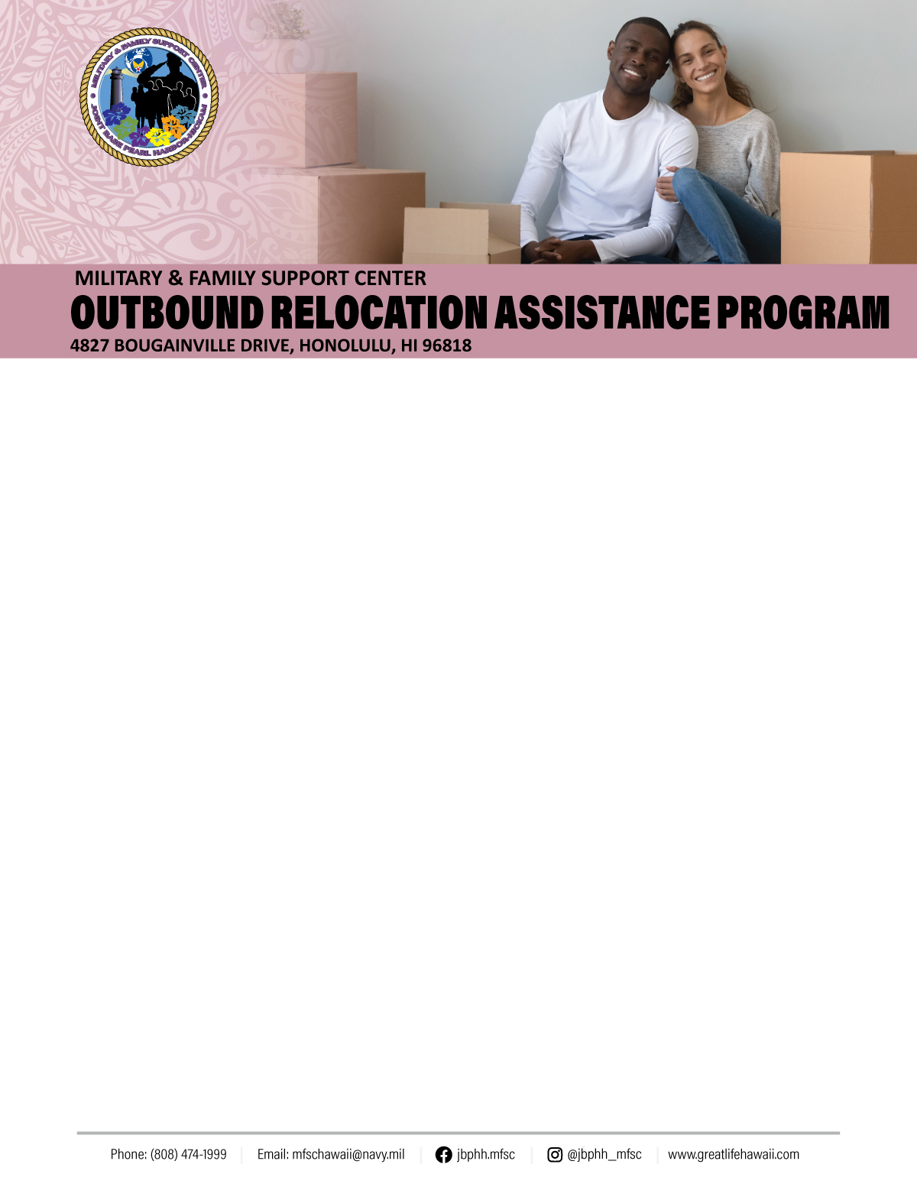

**Lodging**: Both Navy and Air Force may make reservations at either service’s on-base lodging facilities. If you wish to stay off base or there is no availability on base, you must obtain a non- availability statement from lodging. Check out the list of **TLA approved** and **pet friendly** hotels by checking “TLA Approved Hotels” here:

<https://www.cnic.navy.mil/regions/cnrh/installations/jb_pearl_harbor_hickam/ffr/housing_and_lodging/family_and_unaccompanied_housing/housing_services/temporary_lodging_allowance.html>. Please do not rely on word of mouth – get the facts!

**Navy:** 1-800-NAVY-INN (808) 440-2290

**Air Force:** Royal Alakai (808) 800-2330/2337 or (808) 448-5962/5961/5974 (Front Desk)

**All non-availability** statements for **USN and**

**USAF** are issued at **Navy Lodge on Ford Island:** 1275 Saratoga Blvd, Bldg 78

Honolulu, HI 96818-5029, (808) 440-2290 navylodge.hawaii@nexweb.org

**Lodging with Pets:** The <https://hawaii.armymwr.com/programs/family-and-mwr-pet-kennels> can board pets, however, space may be limited. Call (808) 368-3456 for more information.

**Housing/TLA**: Air Force personnel must report to Hickam Communities prior to departure. This is the only organization that can start your Temporary Lodging Allowance (TLA). Navy Personnel will report to their Command CPPA. TLA payment processing, if not done prior to transferring, will need to be done at your new duty assignment.

**Navy:** (808) 474-1820/1821

4825 Bougainville Drive, Honolulu

**7:00 a.m. to 4:30 p.m. Mon-Fri**

**Air Force:** (808) 448-0856/6887

200 Kokomalei St, Honolulu

**7:30 a.m. to 4:00 p.m. Mon-Fri**

Both **Navy & Air Force** on-base housing residents must out-process through their respective Privatized Housing Office: Hunt Companies at [www.ohananavycommunities.com](http://www.ohananavycommunities.com)

and Hickam Communities at [www.hickamcommunities.com](http://www.hickamcommunities.com)

Revised: June 2020

**Shipping A Privately-Owned Vehicle (POV):** Military members are authorized to ship only one POV at government expense.

**International Auto Logistics (IAL)**

**(Pasha Hawaii)**

Forrest Avenue, Pier 1, Honolulu, HI 96813

1-855-389-9499/808-670-3095

8:00 a.m. to 3:00 p.m.

Track your POV: [www.pcsmypov.com](http://www.pcsmypov.com)

**Shipping a 2nd POV?** Looking for a way to ship that second POV back to the mainland without spending a lot of your own money? The OPPORTUNE LIFT (OPLIFT) program might be just what you need. There may be a lengthy wait list for this process and wait time to receive the vehicle at the final destination.

[https://www.cnic.navy.mil/content/cnic/cnic_hq/regions/cnrh/about/](https://www.cnic.navy.mil/content/cnic/cnic_hq/regions/cnrh/about/%20) [regional_departments/comnavsurfgru- midpac/opportune_lift_program.html](http://www.cnic.navy.mil/regions/cnrh/about/regional_departments/comnavsurfgru-midpac/opportune_lift_program.html)

**Sponsorship**: All departing service members should be assigned a sponsor. If you have not been contacted by your sponsor, contact your gaining command/unit or your MFSC/A&RFC RELO managers to assist!

**Major Unit Listing Numbers** can be found at [https://installations.militaryonesource.mil](https://installations.militaryonesource.mil/)

**Smooth Move Class:** An MFSC JBPHH monthly class that features subject matter experts from various departments to give you a better understanding of the PCS process such as: household goods shipments, basic allowances and entitlements, vehicle processing, Tricare/ United Health, researching your new base and

financial planning tips. Whether it’s your first PCS or your last, this class has great information you don’t want to miss! Sign up at: [https://jbphh.greatlifehawaii.com/military-family-support-center/class](https://jbphh.greatlifehawaii.com/military-family-support-center).



**Planning Your Move**: Military One Source provides service members and their families with access to information about their entitlements and benefits, points of contact, checklists, planning tools, and information on education and employment. **Plan My Move** will put you and your family in charge of your next move & smooth relocation experience:

<http://www.militaryonesource.mil/moving> **Plan My Move** also provides you with a three-month calendar of steps you need to take to insure a smooth move for you and your family. You may also create a customized calendar specific to your needs and schedule. To create a customized calendar, return to the Plan My Move homepage and sign-in.

**Looking for Contact Information at the New Base?** Continuously updated by our staff, it’s all right here for you and your family on: <https://installations.militaryonesource.mil>.

**Living off Base at the New Location?** Automated Housing Referral Network (AHRN) ahrn.com is a popular website. It connects military members with housing in the off-base community. AHRN is longer funded by DoD. Available effective 29DEC14 is <https://www.homes.mil>. Also, available is <http://www.rentalsillustrated.com>.

**Household Goods**: The Joint Personal

Property Shipping Office (JPPSO) is responsible for inbound and outbound shipments. Members are required to go online to: <https://move.mil> to process paperwork for shipment of household goods. Updating of your address and delivery information should be done as soon as you arrive at the new base. This website provides the status of shipments and allows users to schedule shipment for delivery when housing is obtained.

For assistance E-Mail [householdsgoods@navy.mil](mailto:householdsgoods@navy.mil).

Navy HHG Website <http://www.navsup.navy.mil/household>.

If you are interested in a **Personally Procured Move (PPM)**, also known as a **“DITY”** move, contact JPPSO at (808) 473-7782.



**Preparing Your Pets**

Departing Hawaii with a pet will require pre- planning. Your pet will need to be medically prepared to ensure they meet the entrance requirements for their final PCS destination whether it be to the mainland or another country.

Like Hawaii, many foreign countries have strict requirements when it comes to moving with your pets. Check with your gaining base to properly prepare your pet. The USDA APHIS website listed here has a list of countries with entrance requirements that can be helpful to reference. https://www.aphis.usda.gov/aphis/ourfocus/animalhealth/export/iregs-for-animal-exports

**A health certificate examination** for your pet by a veterinarian is required within **10 days** of travel. All required vaccinations and tests must be conducted **prior** to the health certificate appointment. Health certificates can be conducted at the JBPHH Veterinary Treatment Facility (VTF), the three other VTFs on Oahu, or a civilian veterinary clinic. Be advised space is limited at VTFs particularly during PCS season so schedule appointments as soon as possible.

You will need to make a reservation with an airline to fly your pet out of Honolulu International Airport. Each airline dictates its own rules regarding transporting animal so contact your air carrier to get details. Be aware that outdoor temperature at your destination or intermediate stops can prevent your pet from traveling depending on the airline. Work closely with the airlines and the organization cutting your travel orders to make a plan that works best for your family and your pet.

It's never too early to start planning to move your pet. So do your research and contact your local Veterinary Treatment Facility if you have any questions

Hickam VTF -Kuntz Avenue Building #1864

Hickam AFB, HI 96853-5246 (808) 449-6481

Revised: June 2020

Revised: July 2020

What was once a two to four-month process is now becoming a six to eight month or longer process. For a military family, this relocation can be a substantial blow to the household budget.

Military and Family Support Center (MFSC) is here to assist you with your employment and re-employment concerns through the Family Employment Readiness Program (FERP). FERP provides, at no cost, a variety of employment services and resources to assist the military family including the transitioning active duty service member, military spouse, family members, and military veterans.

These employment services and resources include classes, workshops, job search skills training, career planning, resume writing, job fairs, interviewing techniques, websites and literature, federal and private sector employment information, and one-on-one consultations. The MFSC at Joint Base Pearl Harbor Hickam is here to provide these services directly to you. For more information on FERP services at MFSC JBPHH, go to **https://[jbphh.greatlifehawaii.com/support/military-family-support-center,](http://www.greatlifehawaii.com/)** call us at 808-474-

1999, or drop by our offices. We look forward to helping you achieve a smooth employment transition.

**Military Spouse Preference (MSP) Priority Placement Program:** Spouses of active duty (AD) military members & full time National Guard/Reserves may be eligible to register for the MSP. To be eligible, spouses must reside within the commuting area of sponsor’s permanent duty station (PDS); provide proof of marriage to the AD member, proof of military member’s AD status, & other documentation required by the vacancy announcement to which you are applying; & must meet all pre-employment criteria & be eligible for immediate noncompetitive appointment to a position in the competitive service. To utilize MSP, build/post a resume to the USAJOBS profile & upload essential documents, including a copy of your sponsor’s PCS orders & the Military Spouse PPP Self-Certification Checklist which must be included with each job application. For more information & FAQs, visit: <https://www.dcpas.osd.mil/EC/Advise>.



**Checking out of the Barracks or Dormitory**: If you are residing in a barracks or dormitory room coordinate with your barracks/dormitory manager. Instructions vary between commands/units.

**Furniture:** All outbound military members and DoD civilians may be authorized temporary loaner furniture. This applies when authorized a household goods shipment. Arrangements should be made three to five business days prior to pack out. Orders required!

***Navy:*** Aloha Furniture at the Housing Service

Center: (808) 474-1820/1821

***Air Force:*** Tunista Furniture located near the back (Kuntz) Gate: (808) 448-0300

**Loan Closet:** Shipped your household goods? Don’t buy temporary things when you can borrow! Items include:

• Pots/Pans/Dishes

• High Chairs

• Vacuums & Small Appliances

**8:00 a.m. to 3:30 p.m., Closed 11:00 a.m. to 12:00 p.m. Tue, Wed, & Thu & the Second Thu of the Month from 12:00 p.m. to 3:30 p.m. for Training**

655 Vickers Ave, Bldg 1105, Honolulu

For more info call: (808) 449-0319

**Employment Assistance**

When a military family relocates, the spouse and family members often must leave behind jobs and careers and income they provide. In the current economy, it is not always an easy process to find new employment at the next destination. Also, veterans that are leaving the military are leaving behind an occupation and will likely need to transition into a private sector or federal civil service job to continue on their career path.

