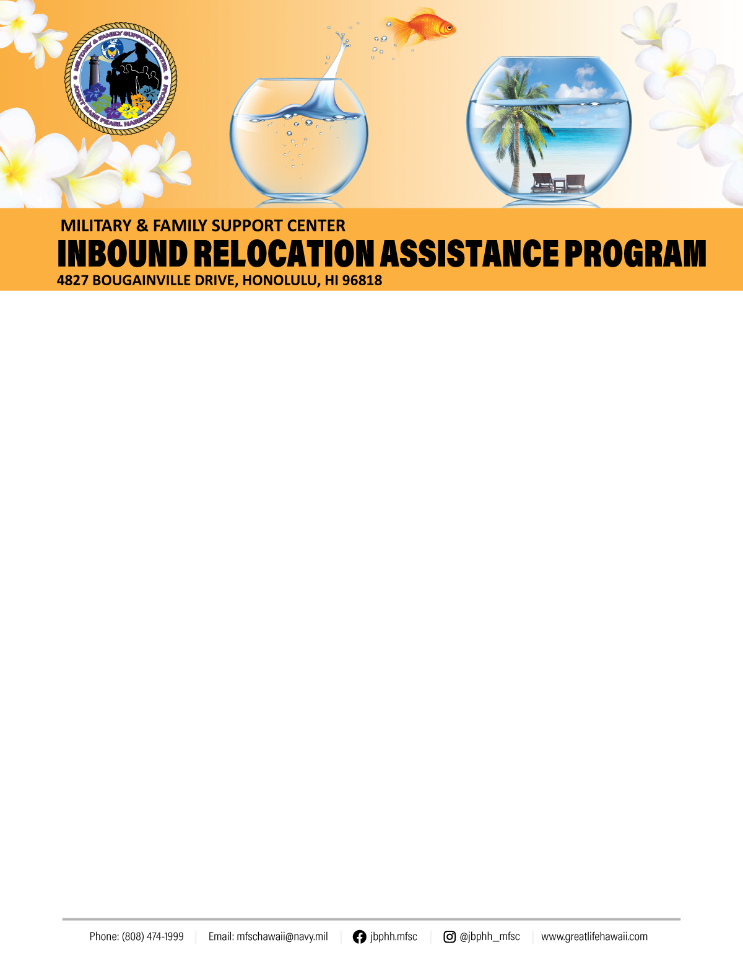
Arrival: In Hawaii you must be 21 years or older to rent a car. The airport is about three miles from the base. Taxis are available at the airport to take you to the main gate of either Pearl Harbor or Hickam. The only commercial company that has access on to the base is “The Cab” (808) 422-2222. Shuttle services are not available, but you may take the “The Bus” to the base. There is an additional cost for luggage. Shuttle service is offered, at a charge, in the following locations: HNL Airport, AMC Terminal, NEX and select lodging and housing areas through ITT Hickam, Mon-Fri from 9 a.m. - 5 p.m. (based on availability). Two large bags per person. Additional bags are subject to an extra charge. Must have a minimum of 2 passengers and a maximum of 14. Reservations are recommended, call 448-2295.
In-processing:
Navy: Must In-process with Command Pay and Personnel Administrator (CPPA), when reporting on board for PSD paperwork processing.
Air Force: Must in-process through MPF. Call (808) 449-8624 Opt 1 or email: 647fss.fsmps@us.af.mil
Hangar 2, 1st Floor, Hickam AFB, Honolulu
Lodging: Both Navy and Air Force may make reservations at either service’s on-base lodging facilities. If you wish to stay off base or there is no availability on base, you must obtain a non-availability letter from lodging. Check out the list of TLA approved and pet friendly hotels at https://www.cnic.navy.mil/regions/cnrh/installations/jb_pearl_harbor_hickam/ffr/housing_and_lodging/family_and_unaccompanied_housing/housing_services/temporary_lodging_allowance.html website. Please do not rely on word of mouth – get the facts!
Navy: 1-800-NAVY-INN (808) 440-2290
Air Force: Royal Alakai 24-Hour Front Desk Reservations 808-800-2330/2337 x6 or (808) 448-5962/5961/5974 (Front Desk) for Group Reservations,.
All Non-Availability Statement (NAS) letters for USN and USAF are issued at Navy Lodge on Ford Island: 1275 Saratoga Boulevard, Bldg 78, Honolulu, HI 96818-5029. (808) 440-2290.
https://www.navy-lodge.com/Hawaii

Pets: The https://hawaii.armymwr.com/programs/family-and-mwr-pet-kennels can board pets, however, space may be limited. Call: (808) 368-3456 for more info and pricing.

Barracks/Dormitory: If you will be residing in a barracks or dormitory room coordinate with your sponsor. Instructions vary between commands/units.
Housing/TLA: All personnel including Paid E-5 and Above on Shore Duty, other than barracks/dormitory residents, must report to their respective Housing Services Center (HSC) within 72 hours of arrival to start their Temporary Lodging Allowance (TLA). The HSCs are also a great place to get information about off-base housing!
Navy: (808) 474-1820/1821
4825 Bougainville Drive, Honolulu
7:00 a.m. to 4:30 p.m. Mon-Fri
Housing Early Application Tool: https://www.cnic.navy.mil/ffr/housing/heat.html
Air Force: (808) 448-0856/6887
200 Kokomalei St, Honolulu
7:30 a.m. to 4:00 p.m. Mon-Fri
Revised: June 2020
Planning Your Move: Military One Source provides service members and their families with access to information about their entitlements/benefits, points of contact, checklists, planning tools, and information on education/employment. Plan My Move will put you and your family in charge of your next move and smooth relocation experience: http://www.militaryonesource.mil/moving. Are you looking for information and points of contact at your new base? Updated four times a year, it’s all right here on: https://installations.militaryonesource.mil.
Household Goods: The Joint Personal Property Shipping Office (JPPSO) is responsible for all inbound and outbound shipments. Processing of household goods is accomplished at https://move.mil . All members are required to go on online to update their address and delivery information as soon as they arrive on base. This website provides the status of shipments and allows users to schedule shipment for delivery when housing is obtained. For assistance E-Mail householdsgoods@navy.mil. Navy HHG Website http://www.navsup.navy.mil/household.
If you will complete a Personally Procured Move (PPM), also known as a “DITY” move, contact JPPSO at (808) 473-7782.
Local Support: Prior to leaving your base check out your local Navy Fleet and Family Support Center (FFSC) or Air Force Airman and Family Readiness Center (AFRC); they offer information and referral resources! Call us, we’ll help you find what you are looking for!
Sponsorship: All newcomers should be assigned a sponsor. If you have not been contacted by your sponsor, call your command/unit or MFSC JBPHH to assist!

Both Navy and Air Force on-base housing is privatized. Hunt Companies, Inc. manages Navy housing, www.ohananavycommunities.com. The Air Force is managed by Hickam Communities housing, www.hickamcommunities.com.
There is a limit of two pets in all privatized housing. Appliances are provided in each home. Exception, Navy Housing does not provide washers and dryers. Navy personnel may apply for housing with the Air Force and vice versa. You will see several of the military services living in the same communities on both bases. You should first apply at your respective service’s housing office before you apply at another office.
Living off Base: Automated Housing Referral Network (AHRN) www.ahrn.com (no longer DoD funded), https://www.hicentral.com, https://www.rentalsillustrated.com, and https://www.homes.mil are popular websites. It connects military members with housing in the off-base community.
Furniture: Military members and DoD civilians may be authorized temporary loaner furniture if they were also authorized a household goods shipment. Arrangements should be made three to five business days prior to move-in. Orders are required!
Navy: Aloha Furniture at the Housing Service Center: (808) 474-1820/1821
Air Force: Tunista Furniture, located near the back (Kuntz) Gate: (808) 448-0300
Loan Closet: Waiting on your household goods to arrive? Don’t buy new when you can borrow! Items include:
- Pots/Pans/Dishes
- High Chairs
- Vacuums and Small Appliances
8:00 a.m. to 3:30 p.m. , Closed from 11:00 a.m. to 12:00 p.m Tue, Wed, and Thu, & 1st Thu closed 12:00 p.m. to 3:30 p.m. for Training :
655 Vickers Ave, Bldg 1105, Honolulu
For more info call: (808) 449-0319
Sailors Attic: No Longer Available.
Phone: 473-0139 jbphhomb@gmail.com

Airman’s Attic: Serves Airmen and Navy in Hawaii E-6 and below. Air National Guard and Reserve Members E6 and below on orders. All other active duty branches E6 and below stationed at JBPHH. Will provide active duty
service members with free and gently used household goods. Located in Bldg 1723 near Kuntz Gate. Tue 10:00 a.m. to 12:00 p.m., Wed 5:30 p.m. to 7:00 p.m., Thu 10:00 a.m. to 1:00 p.m.; 2nd Sat 10:00 a.m. to noon (O3 and Below), (808) 449-5677 or look up at https://www.facebook.com/hickam.attic G-Mail: airmanattichickam@gmail.com.
Must Know On-Base Driving Info: Cell phone use, speeding, and seat belt violations are taken seriously on JBPHH! Click and read about recent changes.
Privately Owned Vehicles (POV): Military members are authorized to ship only one POV at government expense. Once you arrive on island call the Vehicle Processing Center to arrange for pick up.
International Auto Logistics (IAL)
(Pasha Hawaii)
Forrest Avenue, Pier 1
Honolulu, HI 96813
1-855-389-9499/808-670-3095
8:00 a.m. to 3:00 p.m.
Track your POV on: http://www.pcsmypov.com
POV Registration: Newcomers must register their POV with the Hawaii Department of Motor Vehicle Registration (MVR) within 30 days of arrival. Please visit the official website for more information and required documents. Satellite Office is available on JBPHH at the Hickam Main Gate, 1705 O’Malley Blvd, Bldg 192H; Appointment Basis Only. Cash/Check Only;No ATM Machine or Restrooms. Hours: 8:30 a.m. to 12:00 p.m. & 1:00 p.m. to 4:00 p.m. 808-448-0312, https://jbphh.greatlifehawaii.com/recreation/auto-skills/motor-vehicle-registration; https://www.satellitecityhall.com/jbphh-vehicle-registration-office.html; https://www.dmv.com/hi/hawaii/vehicle-registration

Pets/Quarantine: All dogs and cats must go through quarantine. Pets may be eligible for 30 day, five-day or direct release from the airport if requirements are met. Otherwise, pets will be quarantined for 120-days upon arrival. It’s never too soon to start the quarantine process at home!! Department of Agriculture website: http://hdoa.hawaii.gov/ai/aqs/aqs.info/
Base Access: Both Navy and Air Force no longer require DD Form 2220 for Base Decals to enter the installation. Government issued ID cards are sufficient. However, your vehicle is still required to be registered with the Pass and ID Office; to be authorized to be on base. If you have any questions please visit the Visitor Center Bldg 3455 just outside the Pearl Harbor Main (Nimitz) Gate.
Mon - Fri 7:30 a.m. to 3:30 p.m.
(808) 449-0865
*The only military base on Oahu requiring base pass/decal is Marine Corps Base Hawaii, Kaneohe Bay .
Post Office/Mail: Military General General Delivery Mailing Address Infomation: To Request General Delivery Information contact (808) 473-7919/7912 or email: flcph_mailcenter@navy.mil.

Military Personnel may also forward their mail to gaining Command. For further General Mailing Information contact: Regional Mail Center (808) 473- 7919/7912. Please check with your sponsor for procedures. This does not apply for Civilian Personnel and they will need to contact USPS/UPS for a Temporary Mail Box.

Revised: June 2020

