Pearl Harbor
Memorial Chapel
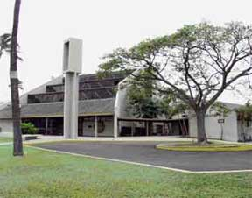

SUN 0815 Roman Catholic Mass
0945 Adult Bible Class (Protestant)
1100 Protestant Worship Service
M,TH,F 1130 Roman Catholic Mass
TUE 0900 Ladies Bible Study (Protestant)
WED 1730 Connect-Grow-Serve Dinner/Bible Study (Protestant)(no meeting from
July 4 thru September 5th)

Aloha Jewish Chapel
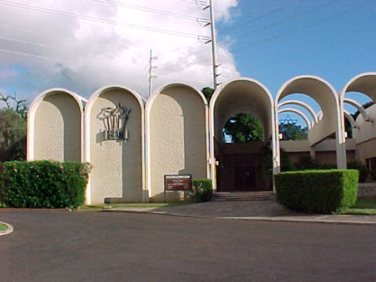

FRI 1930 Kabbalat Shabbat

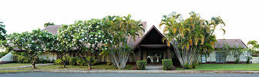
Hickam Chapel Center
SUN 0830 Contemporary Protestant Service
0945 Catholic Religious Education (1-7)
1115 Roman Catholic Mass
1500 AWANA (August-May)
2nd SUN 1230 Catholic Baptism Class Rm 1 & 2
TUE 0900 Catholic Women of the Chapel
1830 Joint Base Protestant Women Bible Study
WED 0830 Joint Base Protestant Women Bible Study
1800 RCIA Class/ 1st Holy / Confirmation
TU, WED 1130 Roman Catholic Mass
SAT 1600 Confession
SAT 1700 Roman Catholic Mass
3rd SAT 1000 Woman 2 Woman Bible Study

NELLES CHAPEL
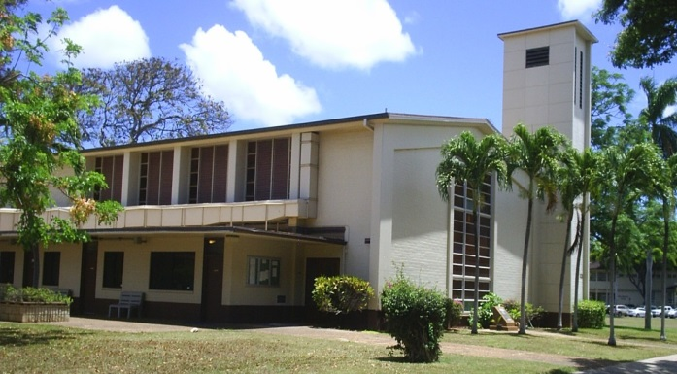

SUN 0845 Protestant Traditional Service
1045 Gospel Protestant Worship Service
1230 Gospel Praise Hula
THUR 1800 Youth Ministry (Nelles/Pearl Harbor)

CHAPEL LOCATIONS

PEARL HARBOR MEMORIAL CHAPEL (BLDG 1601)
On the corner of Pearl Harbor Blvd and Frederick St next to McDonalds.
Telephone: (808) 473-3971/2
Monday–Friday 0730–1600
jbphhchaplains@navy.mil
ALOHA JEWISH CHAPEL (BLDG 1514)
Located across from Makalapa Medical Clinic
Adjacent to Makalapa Gate, Pearl Harbor
HICKAM Chapel Center (bldg 1750)
180 Kuntz Ave
Hickam AFB HI 96853-5149
Telephone: (808) 449-1754
Monday & Wednesday 0900–1630
Tuesday & Thursday 0730-1430
Friday 0730-1400
647abg.hc@us.af.mil
Nelles Chapel (BLDG 500)
On the corner of Signer Blvd. & Ninth St.
Hickam AFB, HI
(Between Library & Medical Clinic)
647abg.hc@us.af.mil
Catholic Coordinator: (808) 449-1761
Catholic Educ Coordinator: (808) 449-1762
Protestant Coordinator: (808) 343-7640
Protestant Educ Coordinator: (808) 449-1762

CHAPEL SPONSORED PROGRAMS

River of Life
Takes place on the 1st Tuesday of the month. All are invited to help serve food to homeless and less fortunate members of the local community. Meet in the back of the Pearl Harbor Memorial Chapel.
Depart for River of Life at 1730.

The Gathering Place (Coffee House)
Airman Ministry Center for Dorm Residents
Bldg 1856 King Hall Dormitory
Dinner every Tuesday night, 1730!
Call Hickam Chapel Center at 449-1754 for more information.

Soup Kitchen
(Catholic Sponsored)
Takes place on the 3rd Tuesday of the Month Meet at the K-Mart (across the street from IHS) at 1525.

Safe Haven & Next Step/H5 Homeless Ministries
(Protestant Sponsored)
Takes place on the 2nd Monday and 4th and 5th Friday of the Month. For more information, contact Chapel Center.

Other Faith Group Opportunities

Church of Jesus Christ of
Latter-Day Saints (LDS)
Russel Harris, CDR (USCG Ret.)
Laura Harris
801-717-6889
ruzzharris@gmail.com
&
Lt Col Darin Fawcett
(406) 836-0651
darin.fawcett@socom.mil

Muslim
Contact (808) 473-4088 for information
Regarding Islamic services

AFTER HOURS CHAPLAIN SUPPORT

For emergency chaplain assistance after normal working hours:

To reach a Navy Chaplain, contact the Joint Base Pearl Harbor-Hickam Quarter Deck at (808) 473-1222.

To reach an Air Force Chaplain, contact the Hickam Command Post at (808) 448-6900 and ask for the Duty Chaplain.

CHAPEL PROGRAMS
&
SERVICES
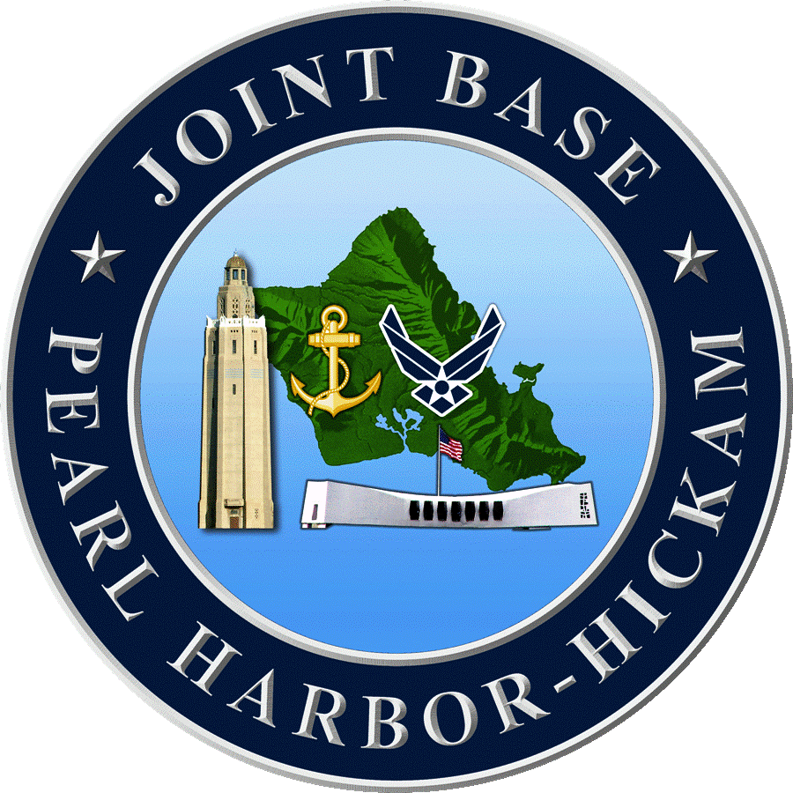

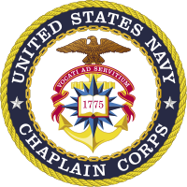
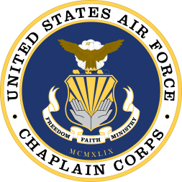

Command Religious Program
Joint Base Pearl Harbor-Hickam

